DevOps Demo Script

VSTS

Instance
Goto https://tfs.visualstudio.com to create a new trial instance. This will allow 5 basic users to connect
It might be recommended to create a new MSA to be the owner for the instance
It does not matter where it places it in the world, default will be USA

Team Project
In the new instance create a new Team project using Git and Agile (choice not that important)

Azure Sub
RIK TO ADD

Code Into VSTS
Open the Team Project, go to Code tab and select ‘import repository’ from the drop down top left
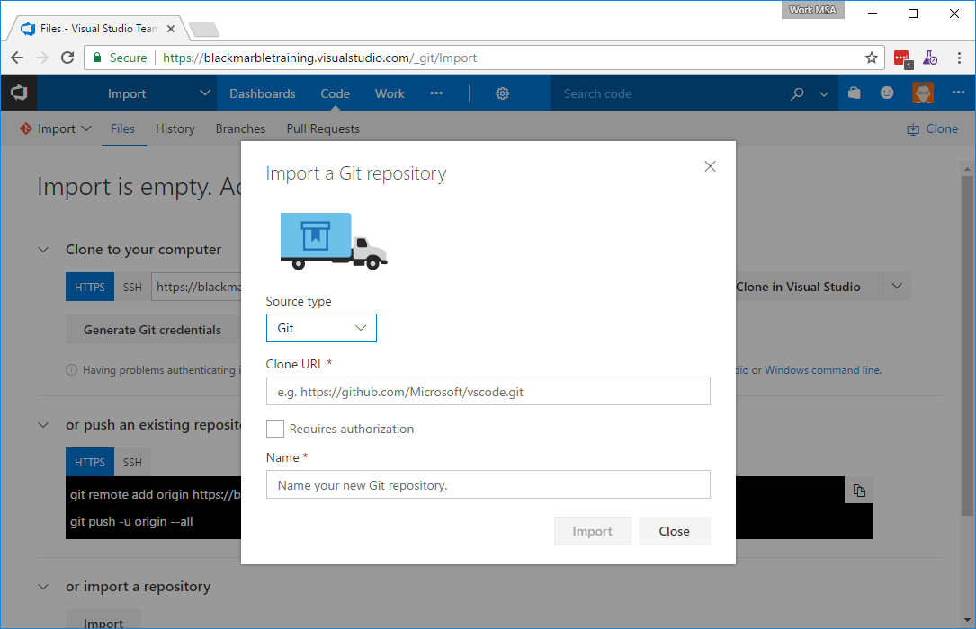
You need to provide the details of the two Labs repos
https://blackmarblelabs.visualstudio.com/DefaultCollection/Labs/_git/Fabrikam
https://blackmarblelabs.visualstudio.com/DefaultCollection/Labs/_git/FabrikamEnv
You will probably require authorization, use your PAT

Extensions
The following VSTS extensions are required to be installed in the VSTS instance
- Richard Fennell’s Manifest Versioning Build Tasks
- Richard Fennell’s Build Tasks
- Colin's ALM Corner Build & Release Tools

Builds
Note that this is subject to change as build tasks get updated beyond our control!

Web Site Build
Pick a Visual Studio default as the starting point

Tasks

Source
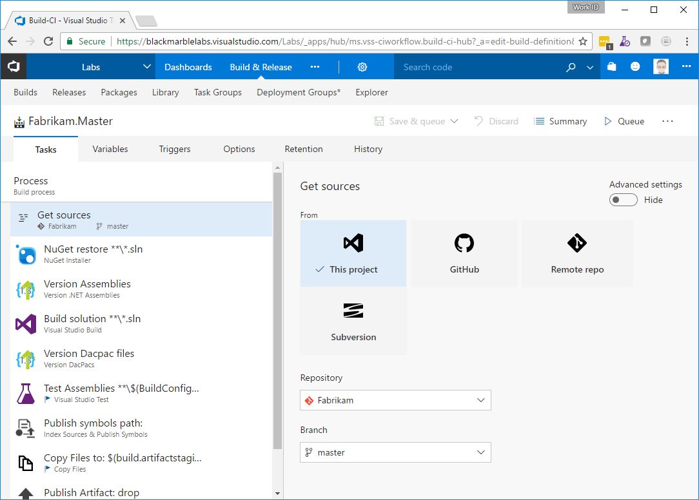

Restore Nuget
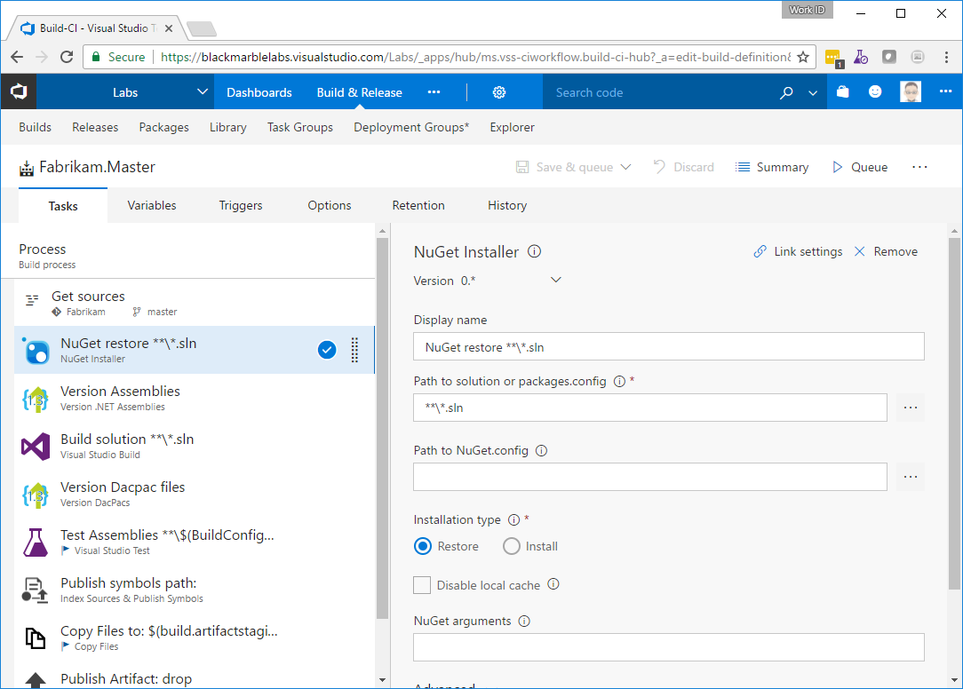

Version Assemblies
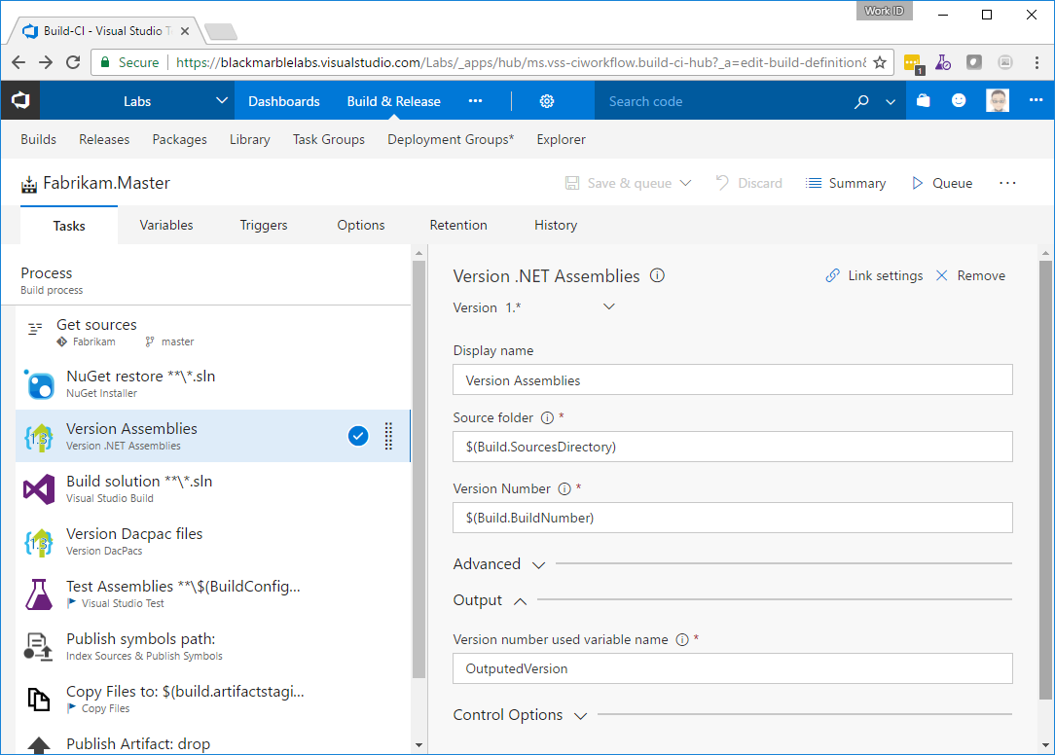

Build solution
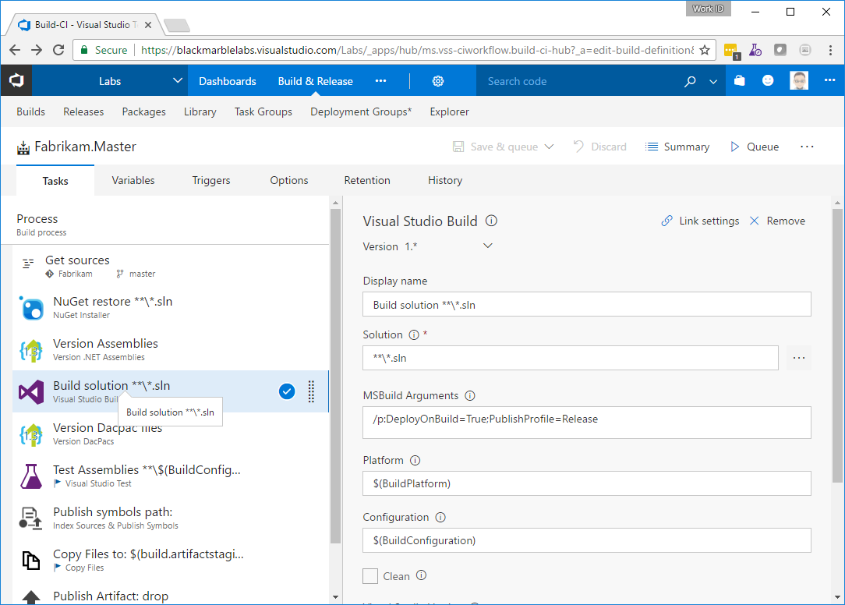
The important line here is /p:DeployOnBuild=True;PublishProfile=Release which creates the MSDeploy Package

Optional – Version DACPAC
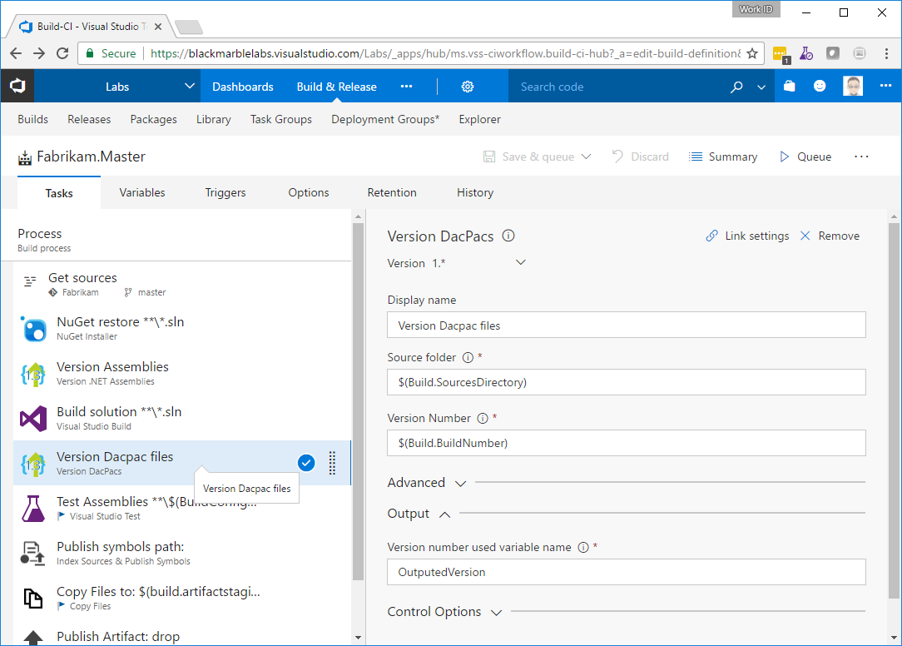
The version DACPAC is optional we don’t actually use it as this is an EF demo

Run Unit Tests
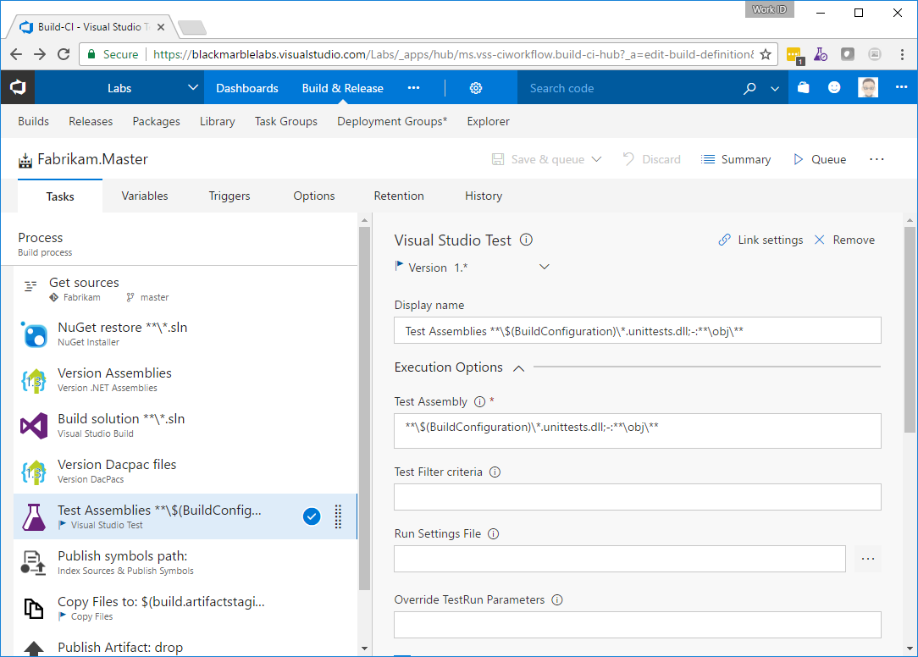

Key item is the assembly filter **\$(BuildConfiguration)\*.unittests.dll;-:**\obj\**

Optional - Publish Symbols
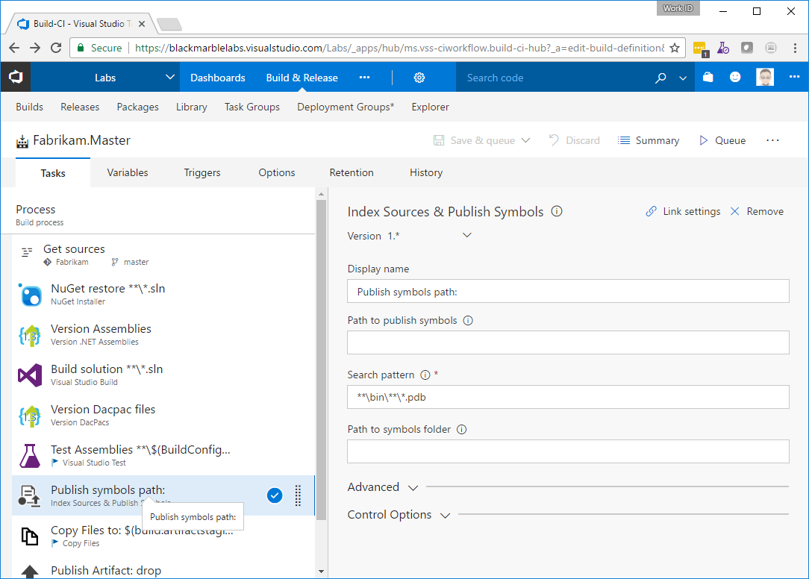

Copy Files
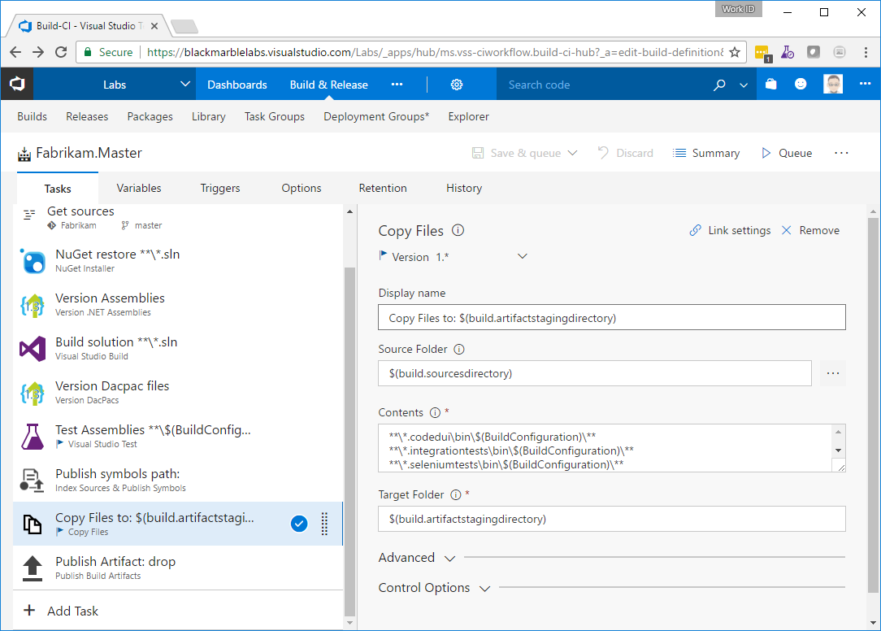
Key item is the list
**\*.codedui\bin\$(BuildConfiguration)\**
**\*.integrationtests\bin\$(BuildConfiguration)\**
**\*.seleniumtests\bin\$(BuildConfiguration)\**
**\_publish\**
**\*.dacpac

Publish
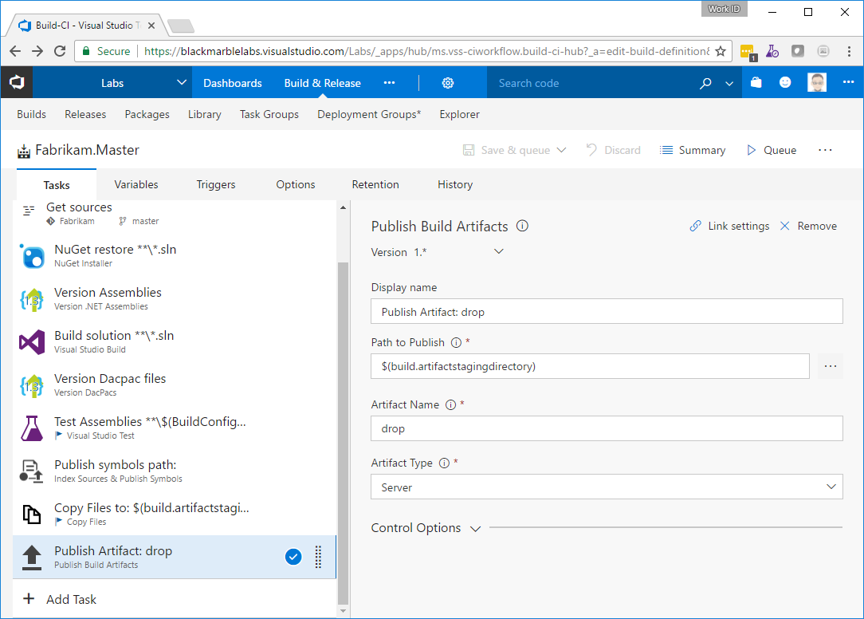

Variables
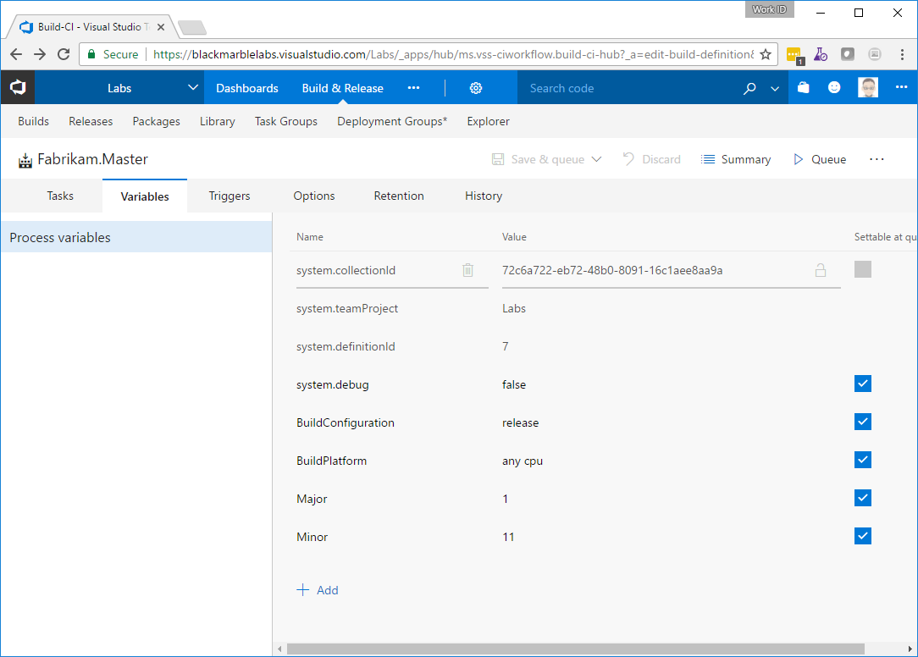

Triggers
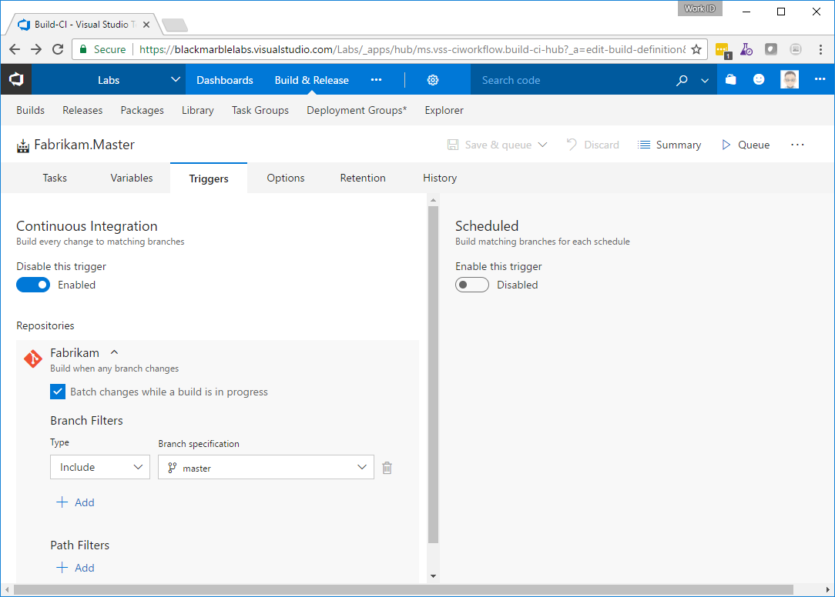

Options
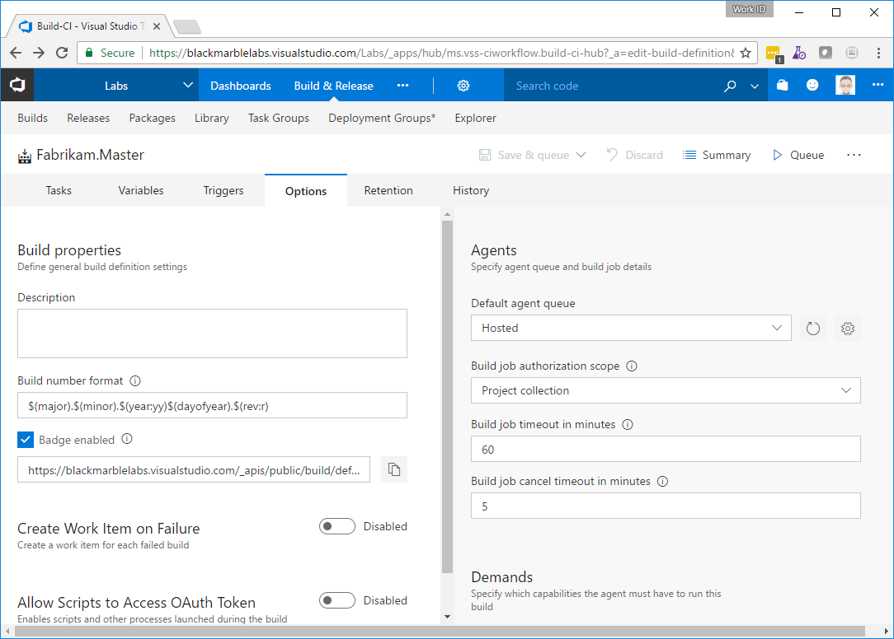

ARM template
Pick and empty as a start point

Tasks

Source
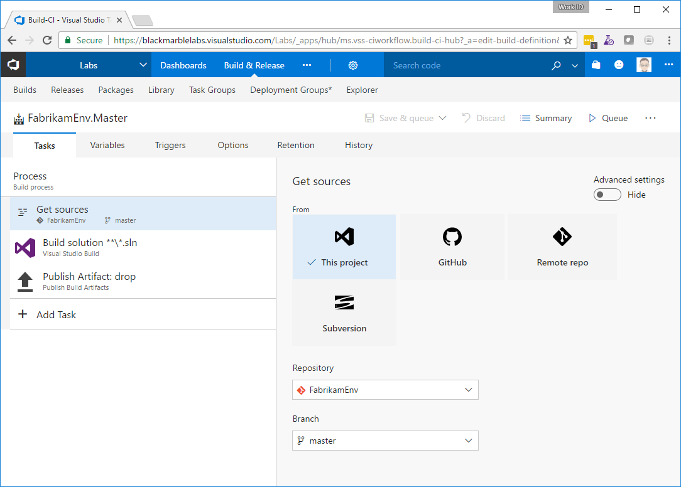

Build Solution
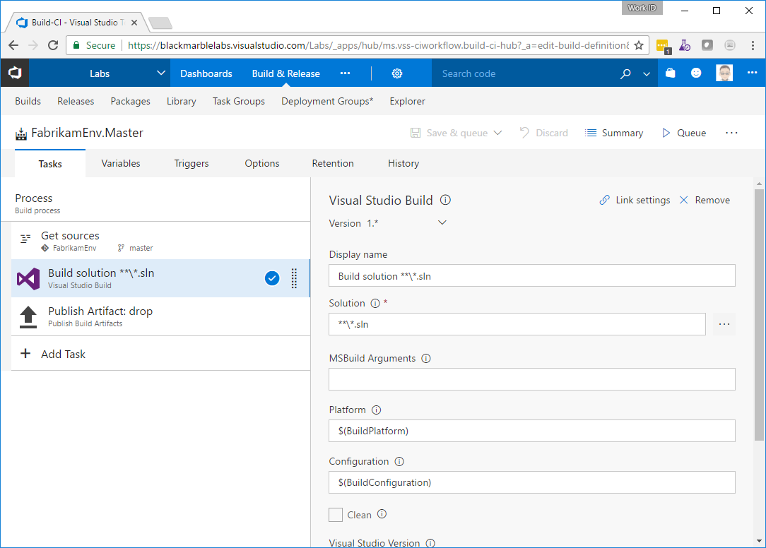

Publish
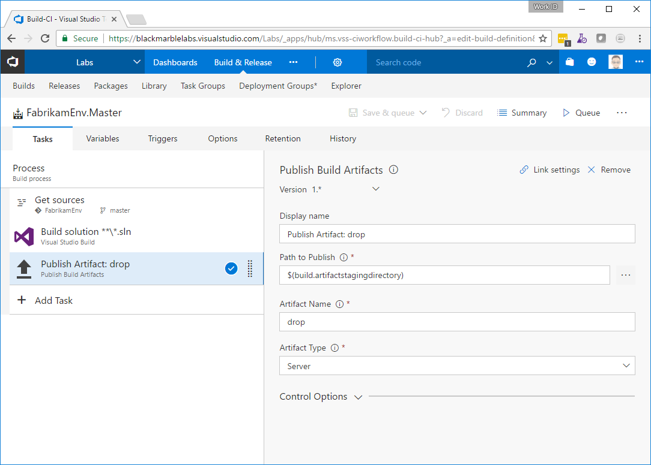

Variables
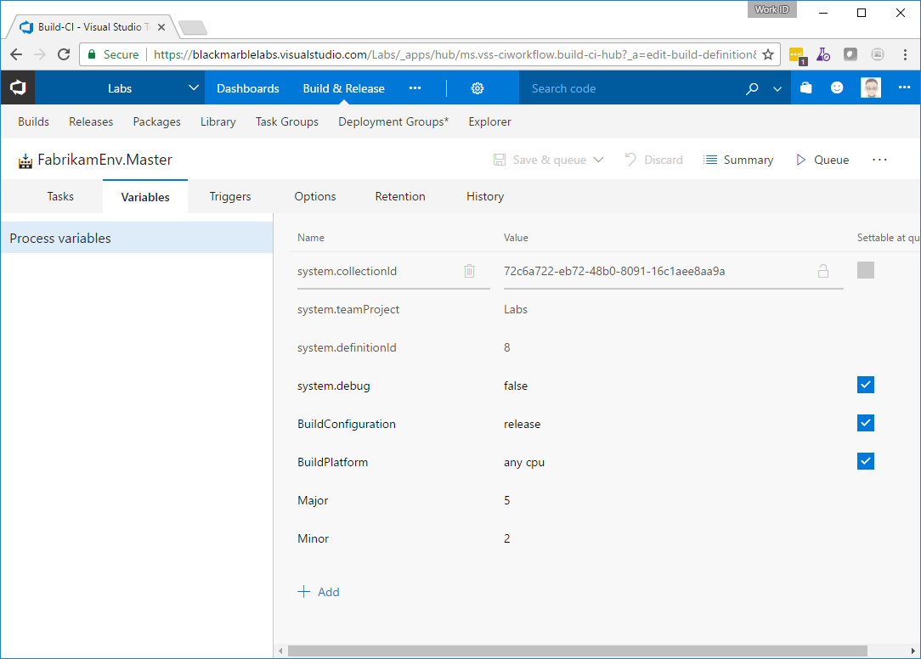

Triggers
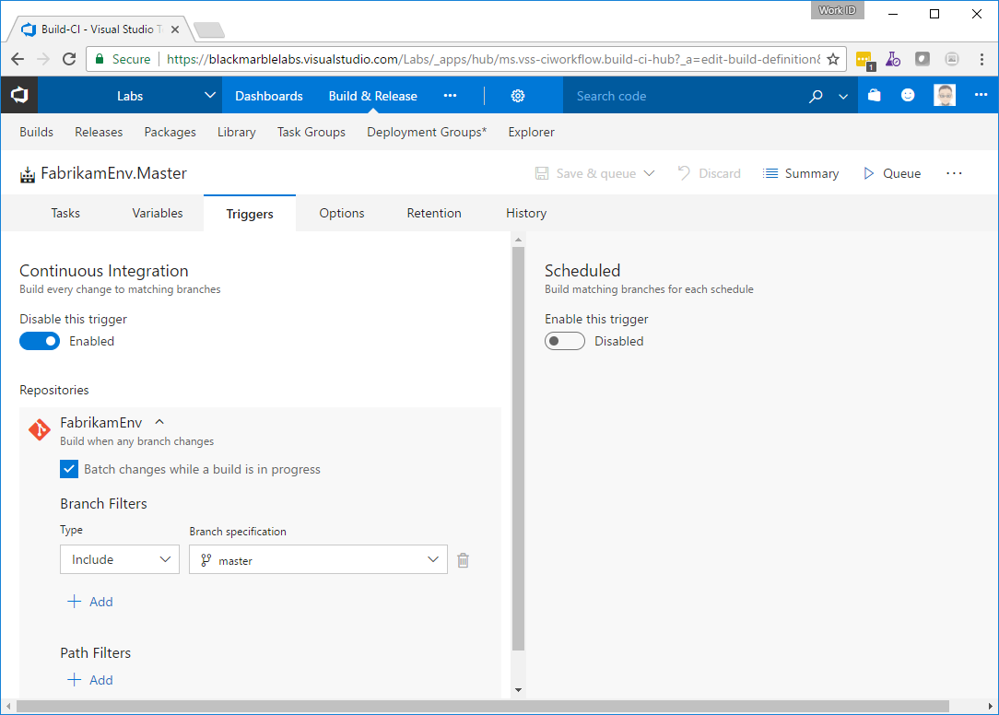

Options
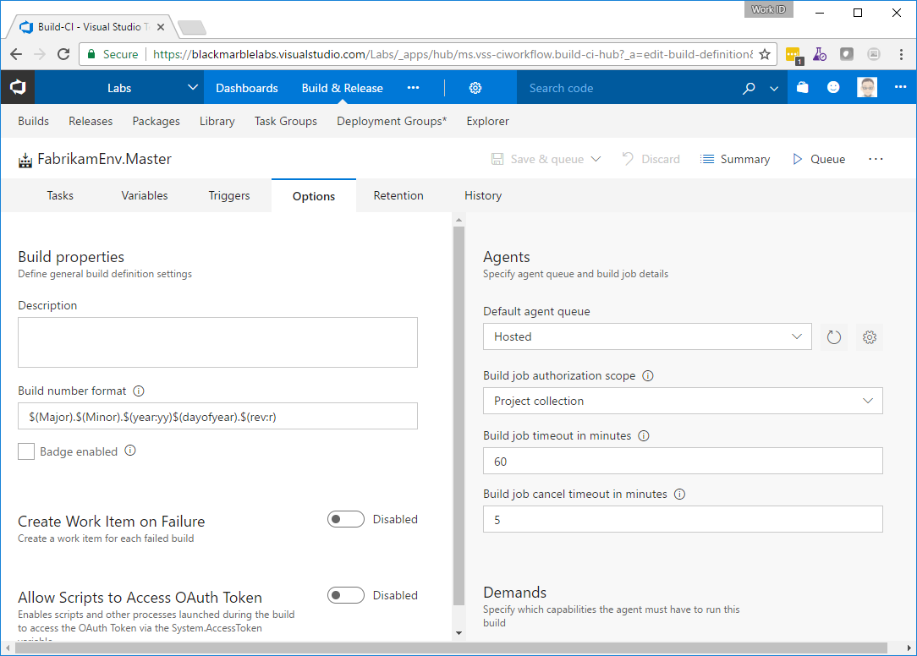

Release

Artifacts
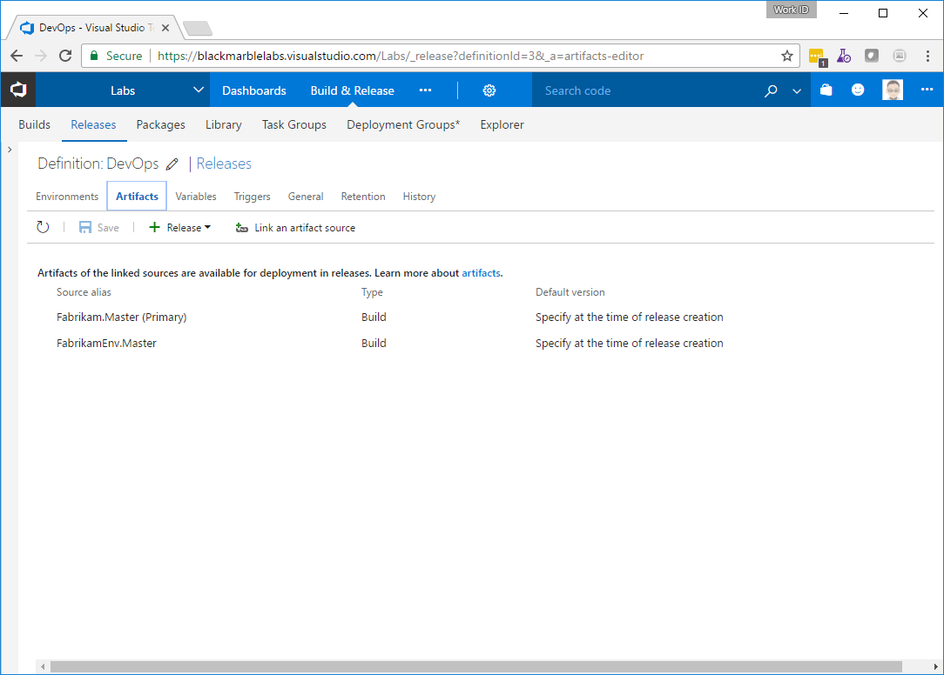

Variables
No process wide ones

Triggers
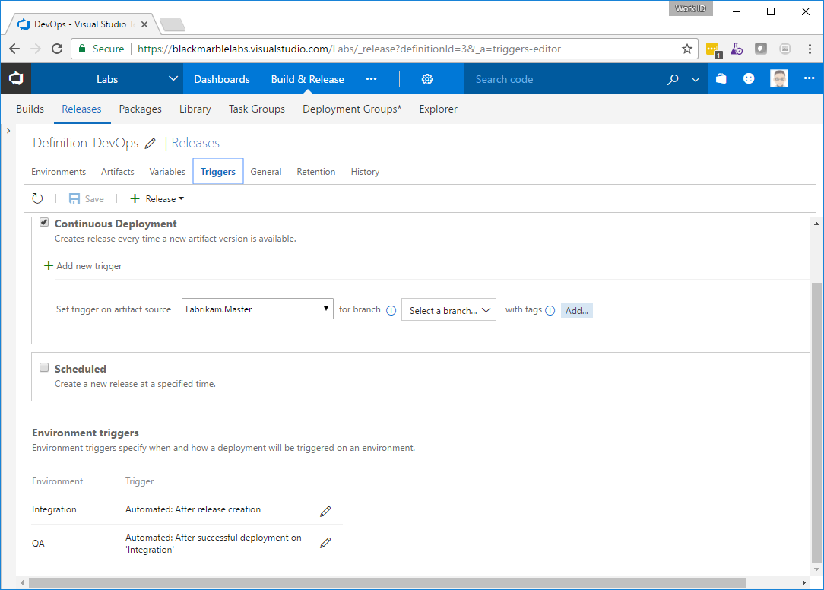

General
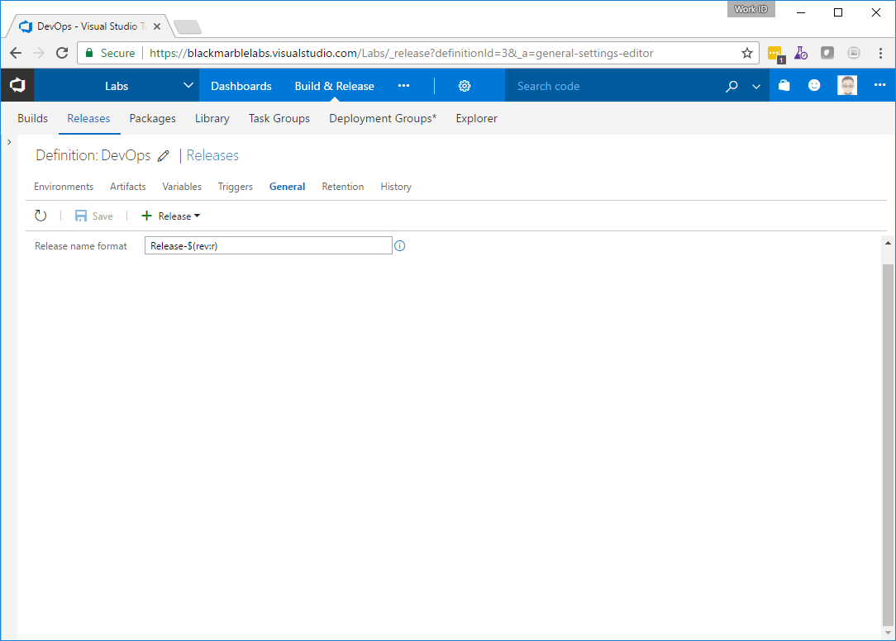

Integration

Tasks

Azure Deploy
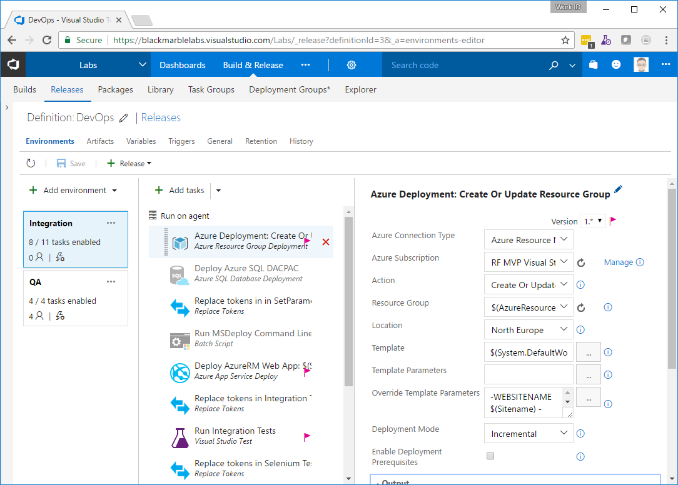
Link to an Azure subscription
Resource group -
$(AzureResourceGroup)
Template - $(System.DefaultWorkingDirectory)/FabrikamEnv.Master/drop/FabrikamEnv/Templates/WebSiteSQLDatabase.json
Overrides –
-WEBSITENAME $(Sitename) -appInsightsLocation $(AppInsightsLocation) -SQLSERVERNAME $(sqlservername) -SQLSERVERADMINLOGIN $(SQLUser) -SQLSERVERADMINPASSWORD (ConvertTo-SecureString $(SQLPassword) -AsPlainText -Force) -DATABASENAME $(databasename)

Optional Deploy DACPac
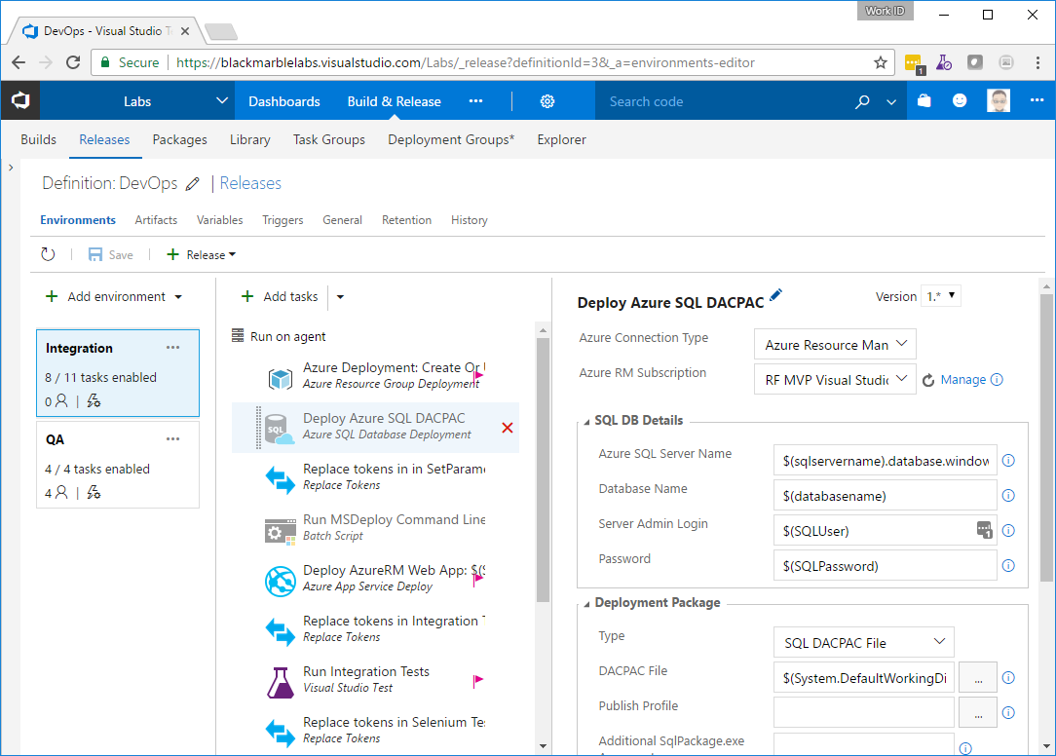
I would skip as not used

Replace Tokens
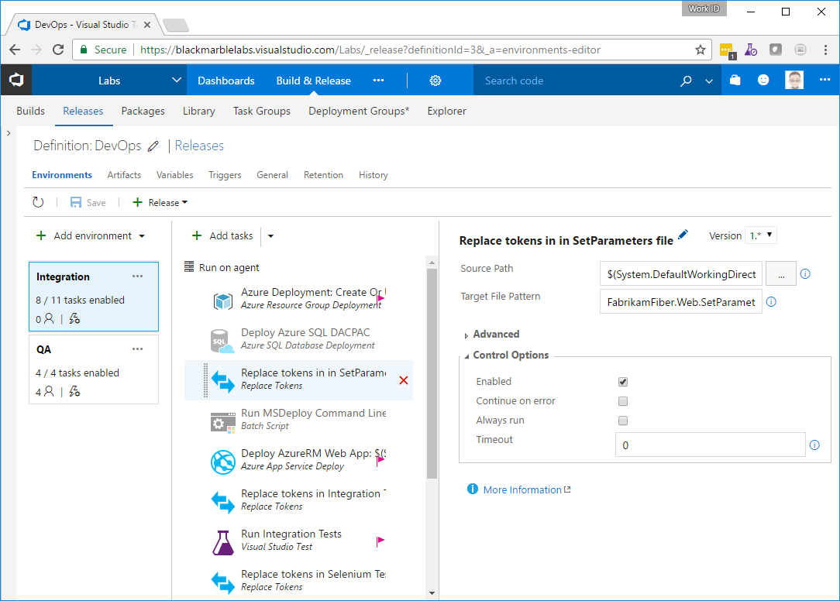
Path
$(System.DefaultWorkingDirectory)/Fabrikam.Master/drop/FabrikamFiber.Web/_publish
Pattern
FabrikamFiber.Web.SetParameters.xml

Run MSDeploy Command line – usually disabled
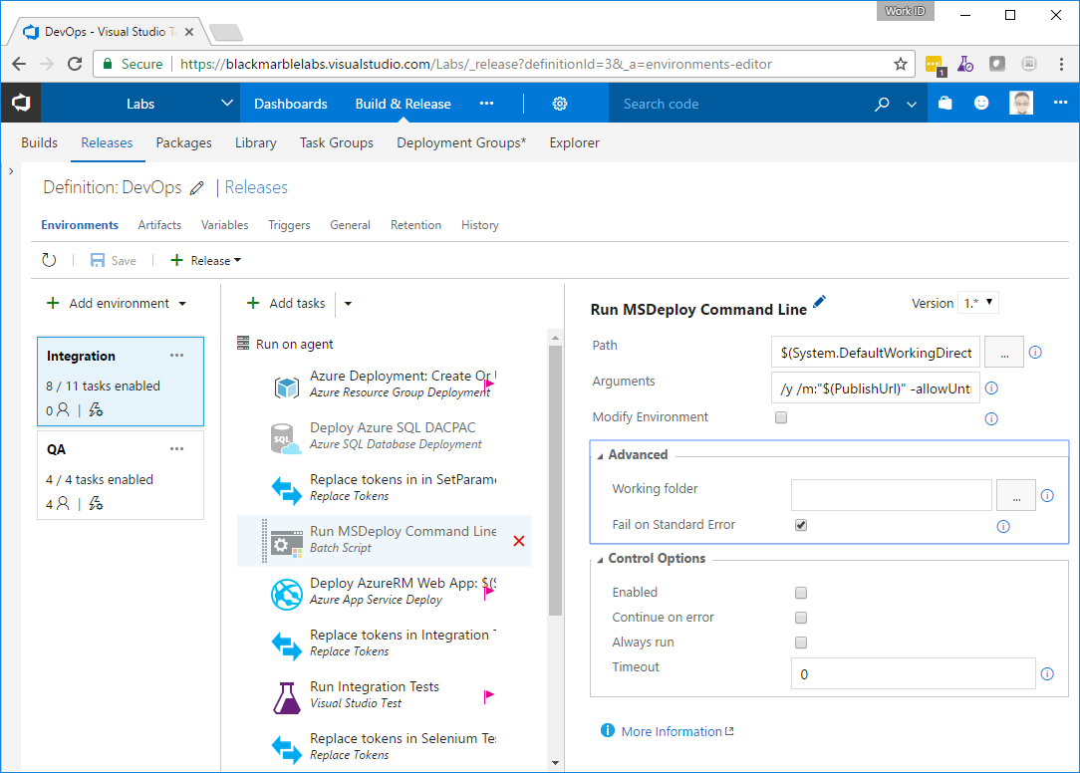
Path
$(System.DefaultWorkingDirectory)/Fabrikam.Master/drop/FabrikamFiber.Web/_publish/FabrikamFiber.Web.deploy.cmd
Args
/y /m:"$(PublishUrl)" -allowUntrusted /u:"$(PublishUser)" /p:"$(PublishPassword)" /a:Basic
Advanced – fail on standard error
USUALLY DISABLED

Azure Deploy
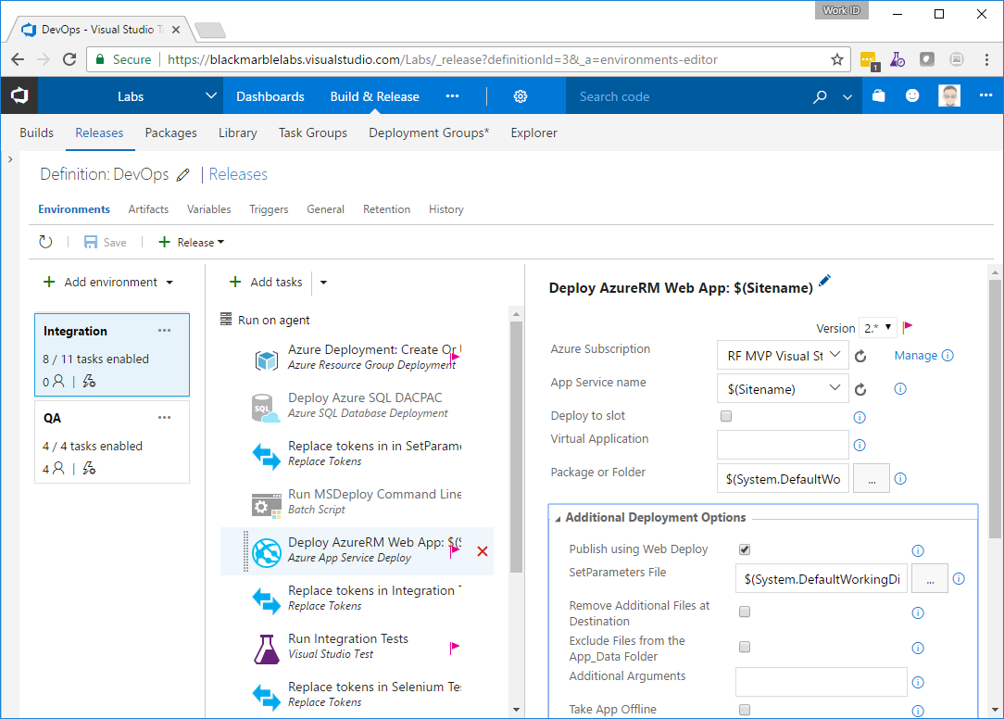
Set Azure sub
Site name
$(Sitename)
Package Folder
$(System.DefaultWorkingDirectory)/Fabrikam.Master/drop/FabrikamFiber.Web/_publish/FabrikamFiber.Web.zip
SetParam file
$(System.DefaultWorkingDirectory)/Fabrikam.Master/drop/FabrikamFiber.Web/_publish/FabrikamFiber.Web.SetParameters.xml

Replace Tokens
Source
$(System.DefaultWorkingDirectory)/Fabrikam.Master/drop/FabrikamFiber.Web.IntegrationTests/bin/Release/
Pattern
FabrikamFiber.Web.IntegrationTests.dll.config

Integration tests
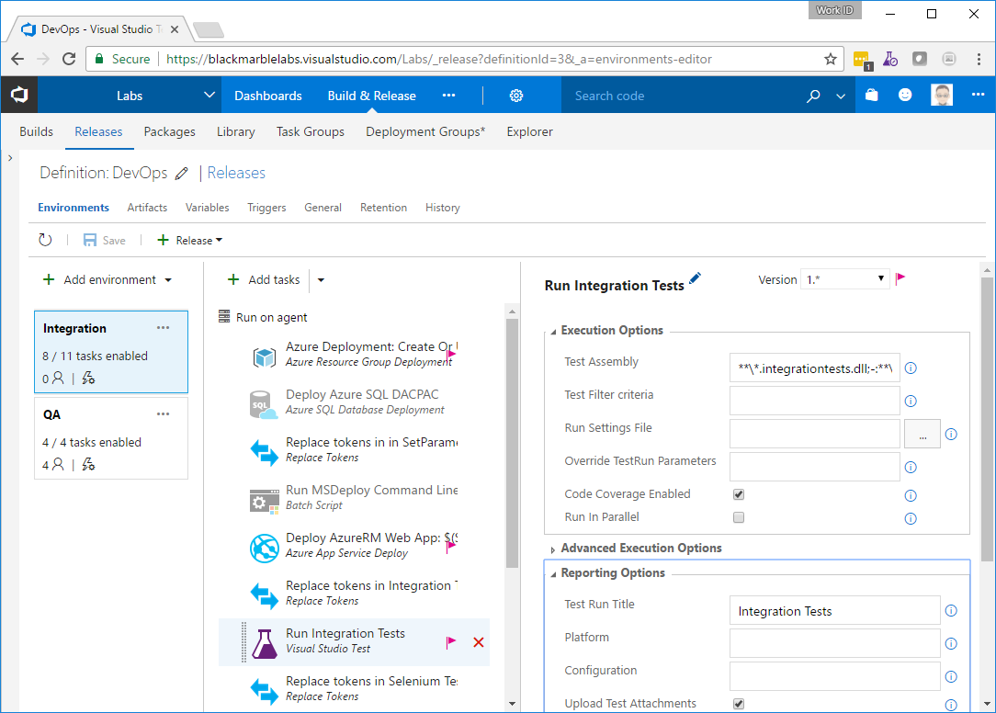
Assembly
**\*.integrationtests.dll;-:**\obj\**
Also set the run title

Replace Tokens
Source
$(System.DefaultWorkingDirectory)/Fabrikam.Master/drop/FabrikamFiber.Web.SeleniumTests/bin/Release/
Pattern
FabrikamFiber.Web.SeleniumTests.dll.config

Run Selenium Tests
Assembly
**\*.seleniumtests.dll;-:**\obj\**
Also set the run title

Delete RG
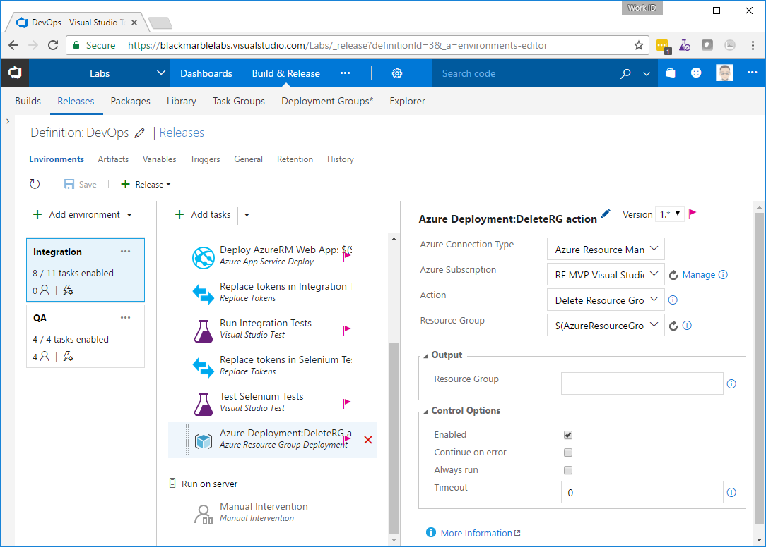

Approvers
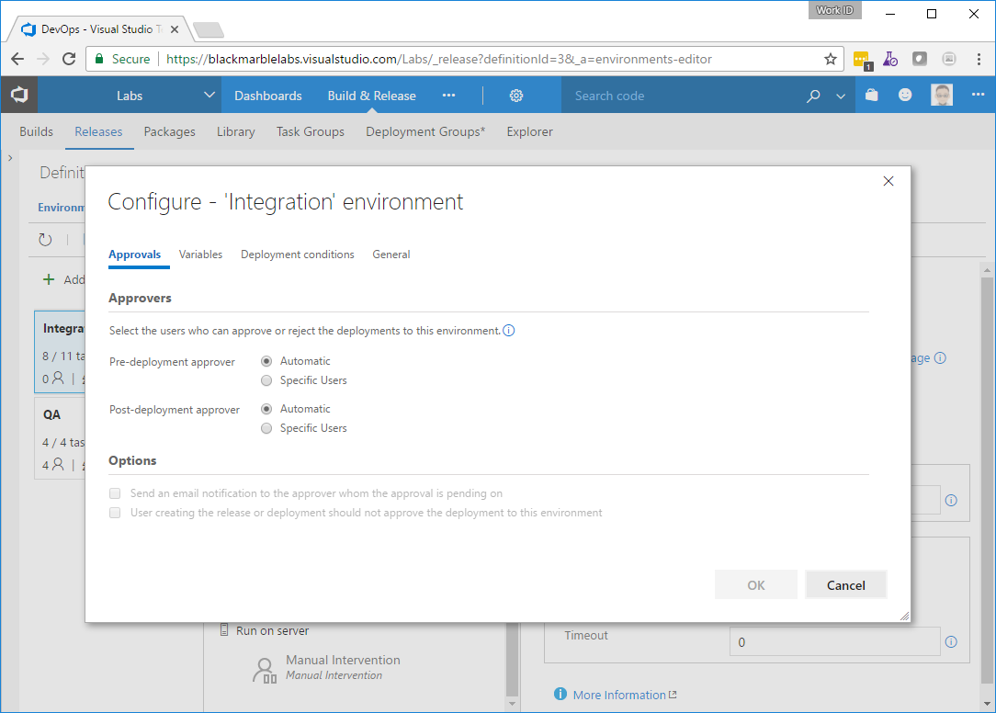

Variables
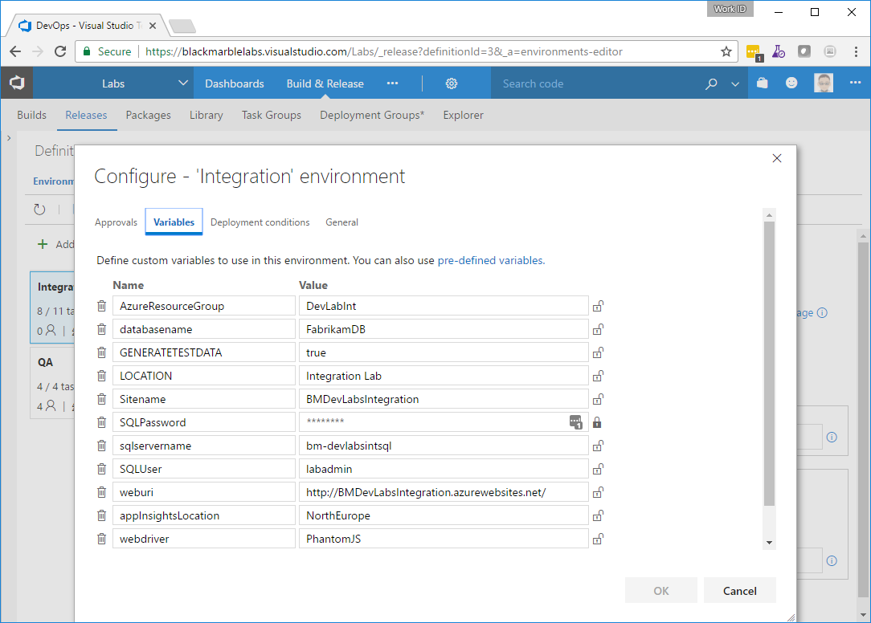

Deployment Conditions
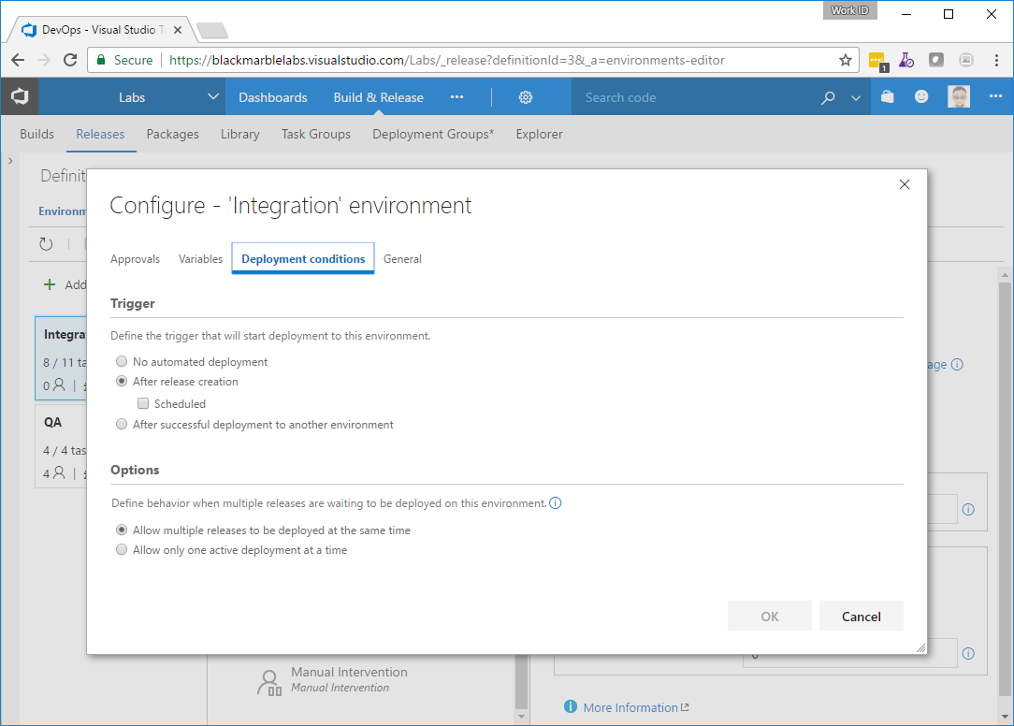

QA

Tasks

Azure Deployment
As Integration

Replace tokens
As Integration

Deploy to Azure RM
As Integration

Update build number
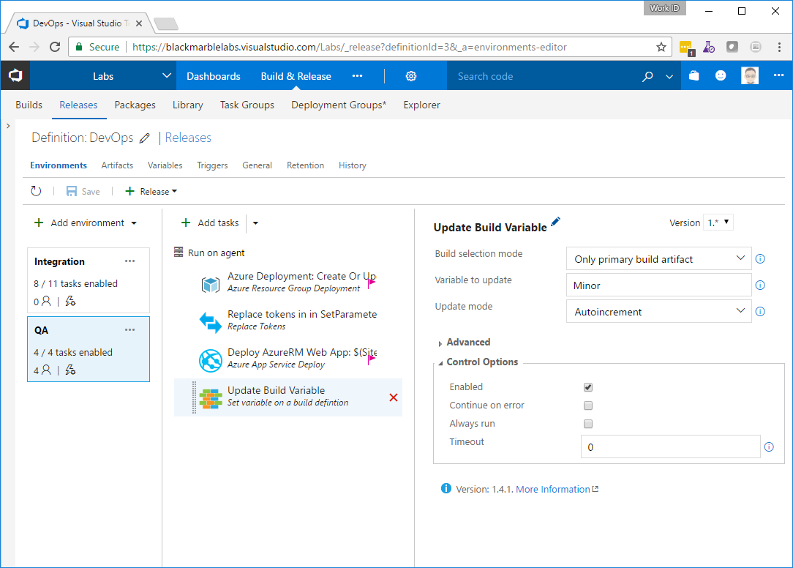

Approvers
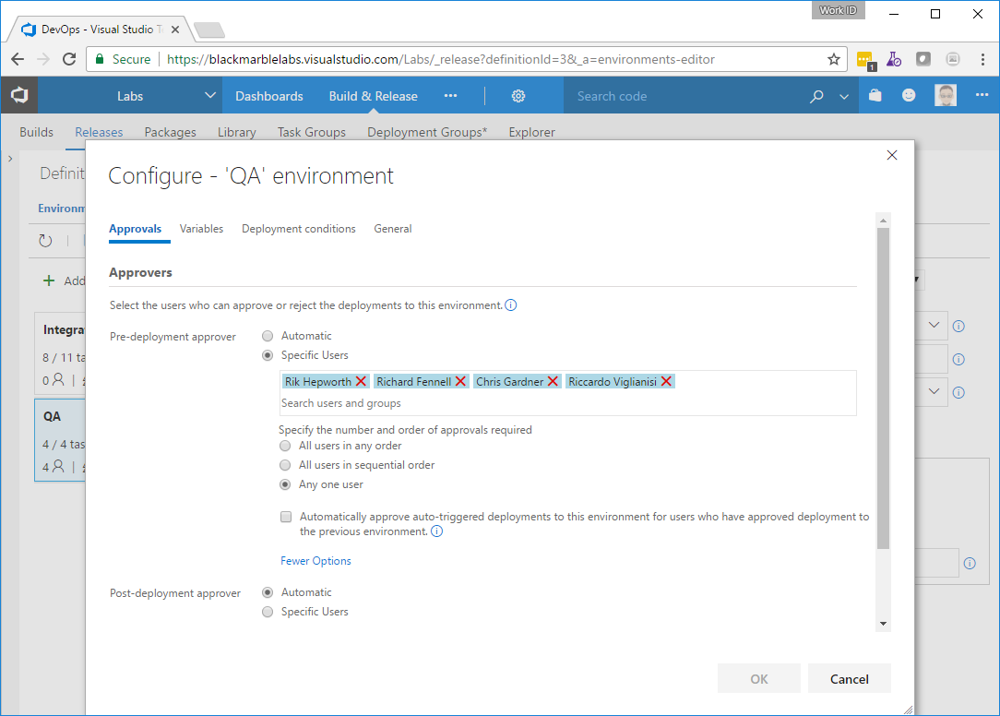

Variables
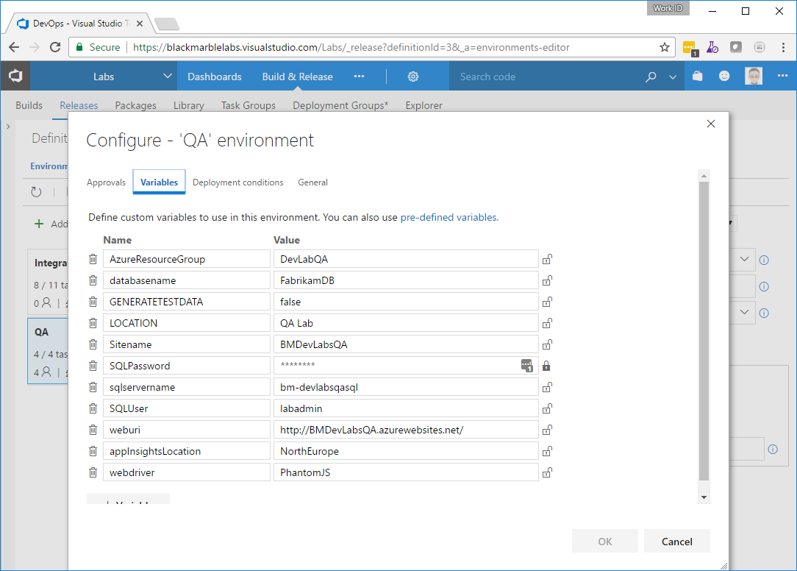

Deployment Conditions
